Table 1. Simulation of TSA ‘s coverage and budget response to an income shock to the economy, depending on the share of wage workers who lose their job in the next six months and the share of income lost by wage workers who remain on the job.
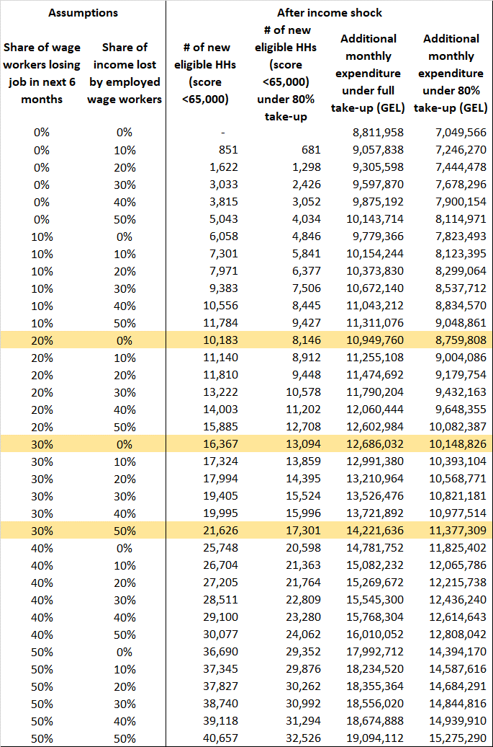
Source: WB calculations based on HIES 2018 data
Methodology: For all households in the dataset, current PMT score is estimated and compared to the counterfactual PMT score if their labor income is either lost in the second last month before submission (if they lose job) or decreased by a fixed percentage if they don’t lose their job. The PMT score and the TSA amount that a HH can claim are calculated based on Res. 145, Res. 758 and following amendments. A HH is considered to be a TSA recipient if they report receiving a positive amount of "Assistance for socially vulnerable families" in the previous two months.
TSA expenditure before the income shock is simulated by assigning each recipient household the amount of TSA that the household qualifies for under the current rules, summarized in the following table.
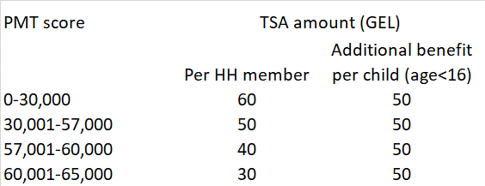
Based on HIES 2018 the coverage and expenditure of TSA (without including the child benefits to households with score between 65000 and 100,000, is the following:
Table 2. Estimated TSA coverage and expenditure , HIES 2018
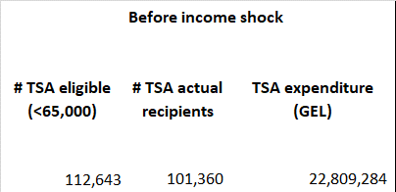

Table 3: Profile of households by PMT score
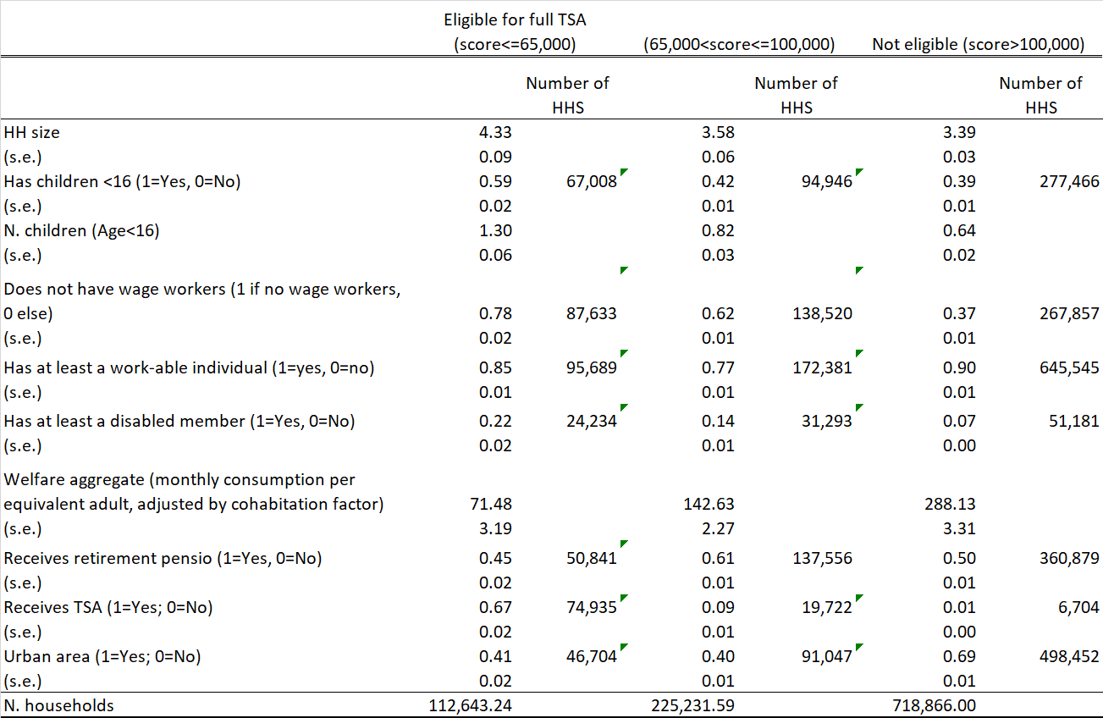
Source: WB elaboration based on HIES 2018 data. The PMT score and the TSA eligibility status are simulated based on Res. 145, Res. 758 and following amendments, as they would apply in March 2020.

Table 4. Estimated coverage of social benefits based on HIES 2018
Source: HIES 2018 data. A household is considered to be a TSA recipient if they report receiving a positive amount of "Assistance for socially vulnerable families" in the previous two months. Associated TSA benefit is average reported by respondents and does not reflect subsequent changes in PMT scoring formula and social assistance transfer amount.
Table 5. Number of households potentially eligible for a one-off emergency benefit (based on HIES
Eligibility conditions: not having members in formal wage work/paying income taxes as verifiable, not receiving social benefit, with children. Note that HIES data do not allow to distinguish between formal and informal wage workers, hence we approximate “formal wage workers” with “public wage workers” (great over-estimation of eligible hh in the last 3 columns).
Table 6. Estimated coverage of social benefits based on LFS 2018
Table 7. Data on potential beneficiary households for a one-off emergency benefit (based on LFS 2018)
Eligibility conditions: not having members in formal wage work (see definition below), not receiving the listed social benefit (see rows in the table), with or without children (see columns in the table).
Note that we define “formal wage workers” as public sector workers plus other wage-workers for whom payroll taxes are paid, with written contract and receiving annual leave and sick leave based on LFS 2018. Note that LFS does not capture well the coverage of TSA (estimated to be as 88,313 households, see Table 3) and other social benefits.

